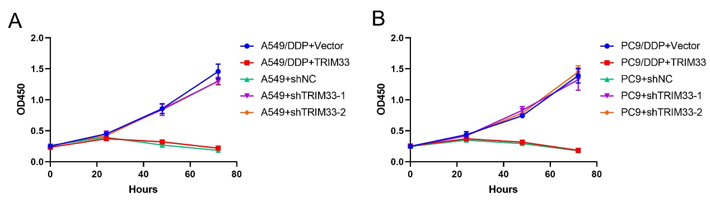
Suppl 5. TRIM33 modulates cisplatin resistance in A549, A549/DDP, PC-9, and PC-9/DDP cells.
(A) Growth curves of A549/DDP cells following TRIM33 overexpression, and A549 cells after TRIM33 knockdown. (B) Growth curves of PC-9/DDP cells following TRIM33 overexpression, and PC-9 cells after TRIM33 knockdown. Data are presented as Mean ± SD (n=6).

