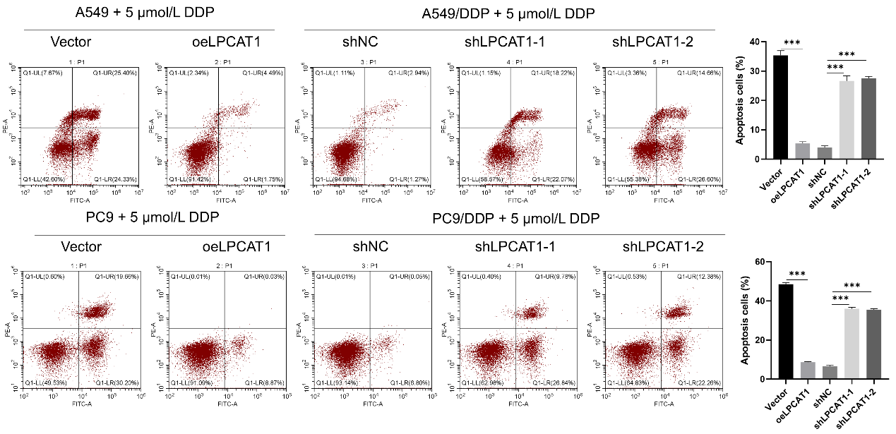
Suppl 3. LPCAT1 inhibits cisplatin-induced apoptosis in NSCLC cells. Data are presented as Mean ± SD (n=3). ***P<0.001.

