Suppl 5. Sensitivity Analysis to Assess Robustness of Meta-Analysis Results
Sensitivity analysis was conducted using the leave-one-out method to evaluate the robustness of the meta-analysis findings. Each study was sequentially excluded from the analysis to determine whether any single study disproportionately influenced the overall results. This method helped assess the stability of the pooled effect estimates for both progression-free survival and overall survival.

PFS Sensitivity Analysis: Impact of Individual Studies on Progression-Free Survival Estimates
HNSCC
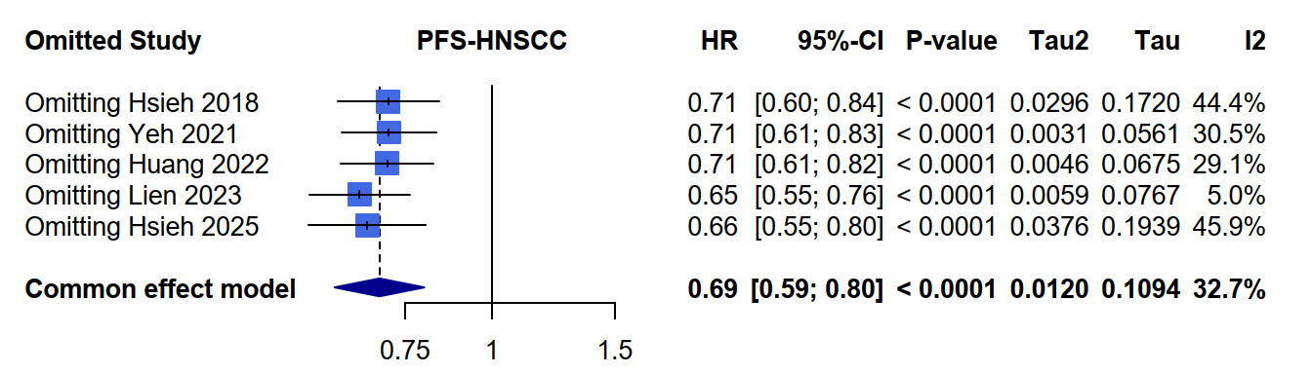

OS Sensitivity Analysis: Impact of Individual Studies on Overall Survival Estimates
HNSCC
