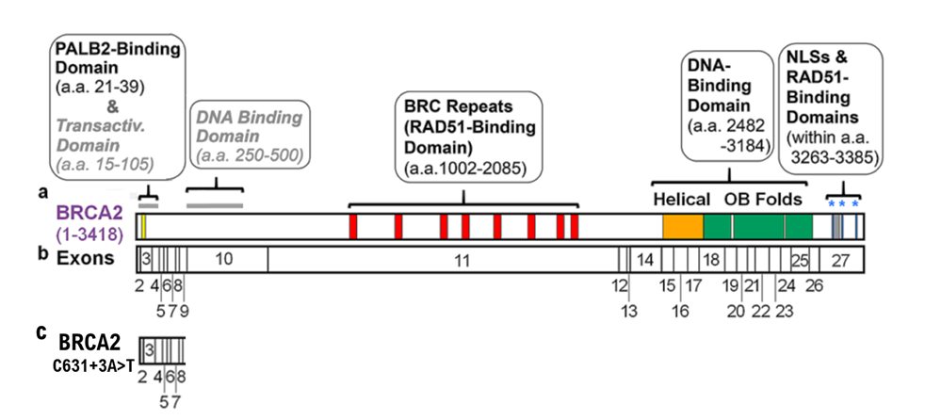

**Suppl 5.** Diagram of the positions of identified domains in human BRCA2 and of the 27 exons that encode human BRCA2 product. **(a)** At the extreme N-terminus of BRCA2 is a PALB2-binding domain (yellow bar) from a.a. 21 to 39. The central region of BRCA2contains aRAD51-bindingdomainfroma. a. 1002to2085, including 8 BRC repeats (red bars, BRC1: a.a. 1002–1036, BRC2: a.a. 1212–1246, BRC3: a.a. 1421–1455, BRC4: a.a. 1517–1551, BRC5: a.a. 1664–1698, BRC6: a.a. 1837–1871, BRC7: a.a. 1971–2005, and BRC8: a.a. 2051–2085), and intervening sequences. There is also a prominent DNA-binding domain (DBD) at the C-terminus of BRCA2 (C-DBD), spanning a.a. 2482–3184, which includes a helical domain (a.a. 2482–2668, orange bar) and three OB folds (OB1: a.a. 2670–2803, OB2: a.a. 2808–3049, and OB3: a.a. 3055–3184, each shown as a green bar). There is an additional RAD51-binding domain at the extreme C-terminus of BRCA2 (a.a. 3270–3305, grey Figure 1. Diagram of the positions of identified domains in human BRCA2 and of the 27 exons that encode this protein. **(a)** At the extreme N-terminus of BRCA2 is a PALB2-binding domain (yellow bar) from a.a. 21 to 39. The central region of BRCA2 contains a RAD51-binding domain from a.a. 1002 to 2085, including 8 BRC repeats (red bars, BRC1: a.a. 1002 1036, BRC2: a.a. 1212–1246, BRC3: a.a. 1421–1455, BRC4: a.a. 1517–1551, BRC5: a.a. 1664–1698, BRC6: a.a. 1837–1871, BRC7: a.a. 1971–2005, and BRC8: a.a. 2051–2085), and intervening sequences (3,4). There is also a prominent DNA-binding domain (DBD) at the C-terminus of BRCA2 (C-DBD), spanning a.a. 2482–3184, which includes a helical domain (a.a. 2482 2668, orange bar) and three OB folds (OB1: a.a. 2670–2803, OB2: a.a. 2808–3049, and OB3: a.a. 3055–3184, each shown as a green bar). There is an additional RAD51-binding domain at the extreme C-terminus of BRCA2 (a.a. 3270–3305, grey bar). On either side of this motif are three putative nuclear localization signals (NLS) (NLS1: a.a. 3263–3269, NLS2: a.a. 3311–3317 and NLS3: a.a. 3381–3385) indicated by blue asterisks and bars. A less well characterized N-terminal DBD (N-DBD), present at a.a. 250–500, and a potential transactivation activity revealed via fusion to other factors (present at a.a. 18–105), are shown by a grey line and indicated with grey/italicized text because of uncertainty about their physiological relevance. **(b)** Exons of BRCA2 are shown relative to the portions of the BRCA2 protein **(a)** they encode. Exons of BRCA2 by the amino acids they encode: exon 2 (a.a. 1–22), exon 3 (a.a. 23–105), exon 4 (a.a. 106–141), exon 5 (a.a. 142–158), exon 6 (a.a. 159–172), exon 7 (a.a. 173–210), exon 8 (a.a. 211–227), exon 9 (a.a. 228–264), exon 10, (a.a. 265–636), exon 11 (a.a. 637–2280), exon 12 (a.a. 2281–2312), exon 13 (a.a. 2313–2335), exon 14 (a.a. 2336–2478), exon 15 (a.a. 2479 2539), exon 16 (a.a. 2540–2601), exon 17 (a.a. 2602–2658), exon 18 (a.a. 2659–2777), exon 19 (a.a. 2778–2829), exon 20 (a.a. 2830–2877), exon 21 (a.a. 2878–2918), exon 22 (a.a. 2919–2984), exon 23 (a.a. 2985–3039), exon 24 (a.a. 3040–3085), exon 25 (a.a. 3086–3167), exon 26 (a.a. 3168–3216), and exon 27 (a.a. 3217–3418). bar). On either side of this motif are three putative nuclear localization signals (NLS) (NLS1: a.a. 3263–3269, NLS2: a.a. 3311–3317 and NLS3: a.a. 3381–3385) indicated by blue asterisks and bars. A less well characterized N-terminal DBD (N-DBD), present at a.a. 250–500, and a potential transactivation activity revealed via fusion to other factors (present at a.a. 18–105), are shown by a grey line and indicated with grey/italicized text because of uncertainty about their physiological relevance. **(b)** Exons of BRCA2 are shown relative to the portions of the BRCA2 protein **(a)** they encode. Exons of BRCA2bytheaminoacidsthey encode: exon 2 (a.a. 1–22), exon 3 (a.a. 23–105), exon 4 (a.a. 106–141), exon 5 (a.a. 142–158), exon 6 (a.a. 159–172), exon 7 (a.a. 173–210), exon 8 (a.a. 211–227), exon 9 (a.a. 228–264), exon 10, (a.a. 265–636), exon 11 (a.a. 637–2280), exon 12 (a.a. 2281–2312), exon 13 (a.a. 2313–2335), exon 14 (a.a. 2336–2478), exon 15 (a.a. 2479–2539), exon 16 (a.a. 2540–2601), exon 17 (a.a. 2602–2658), exon 18 (a.a. 2659–2777), exon 19 (a.a. 2778–2829), exon 20 (a.a. 2830–2877), exon 21 (a.a. 2878–2918), exon 22 (a.a. 2919–2984), exon 23 (a.a. 2985–3039), exon 24 (a.a. 3040–3085), exon 25 (a.a. 3086–3167), exon 26 (a.a. 3168–3216), and exon 27 (a.a. 3217–3418). **(c)** The BRCA2 C631+3A>T variant does not contain a DNA binding domain, a BRC repeat (RAD51 binding domain), a DNA binding domain, NLSs & a RAD51 binding domain. Therefore, the BRCA2 C631+3A>T variant does not have a DNA repair function.