A
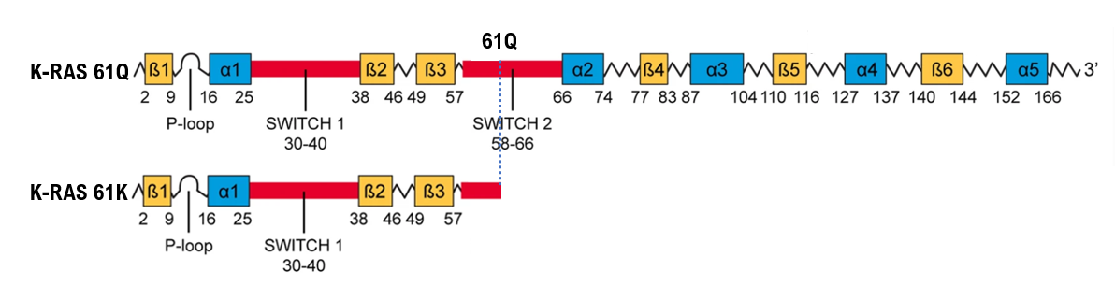
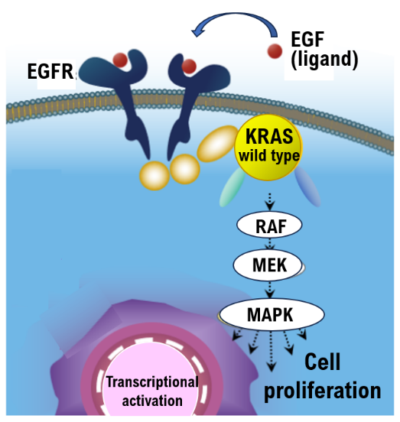
B

Suppl 2. The structure and functional sites of KRAS. A. Crystal structure of KRAS in the active GTPγS (a non-hydrolyzable GTP analog)-bound state (PDB ID: 4DSO). Schematic of functional sites of KRAS. KRAS dimerization involves several different ‘α4–α5’ surfaces, as determined using NMR and X-ray crystallography, and the β-sheet region including Switch I and II sites binds to RAS effectors (e.g., RAF, PI3Kγ) or regulators (e.g., GAP, GEF). The amino acid sequence of KRAS. Residues 12, 13, and 61, whose single-point mutations are associated with many human cancers and malignant tumors, are indicated as black arrows. Secondary structure content is indicated at the bottom of the sequence with α-helices (blue) and β-strands (yellow). Nucleotide binds to a conserved phosphate-binding loop (P-loop comprising residues 10–17, green). Switch I (residues 30–40) and Switch II (residues 58–72) regions and disordered C-terminal polybasic region (PBR, residues 172–184) are colored red, violet, and blue, respectively. The K-RAS 61K mutant lacks amino acids 62 and onward, so it does not bind to BRAF or MEK. Therefore, K-RAS 61K variant cannot induce EGFR signaling.
B. Anti-EGFR antibody drugs are molecular targeted drugs that bind to the extracellular domain of EGFR and inhibit ligand-dependent downstream signaling of EGFR. The use of anti-EGFR antibody drugs has been approved for the treatment of advanced colorectal cancer, and antitumor effects of drug therapy for colorectal cancer are expected. However, once the RAS gene mutates to become activated RAS, the activation of RAS cannot be suppressed even by administering anti-EGFR antibody drugs. As a result, anti-EGFR antibody drugs cannot be expected to be effective against mutated, activated RAS.

