Luminal A Luminal B
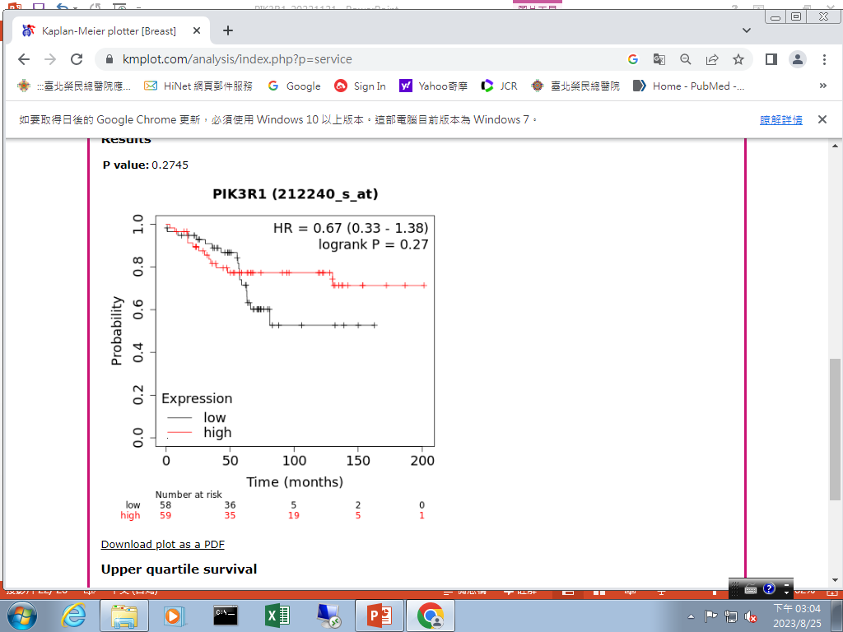
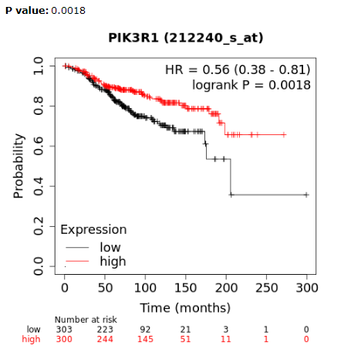

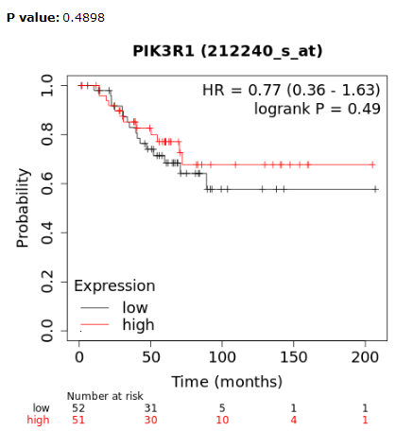
HER2-enriched Triple negative
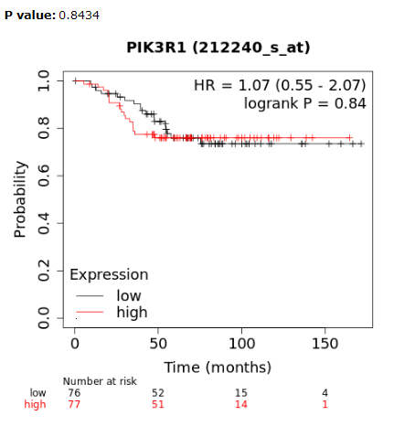

Suppl 7. The role of PIK3R1 on cell growth of the MCF-7 (ER+/HER2 low) cell line. After PIK3R1 gene was knocked down on the MCF-7 line, cell cycle analysis demonstrated a significant decrease in the G0G1-fraction and increased S-fraction, but not the S+G2M-fraction (A) in Δ PIK3R1 MCF-7 cell line. Western blot analysis showed no significant changes in the p-AKT and p-mTOR protein expression (B) in Δ PIK3R1 MCF-7 line, compared to the equivalent WT line.

