HER2-enriched
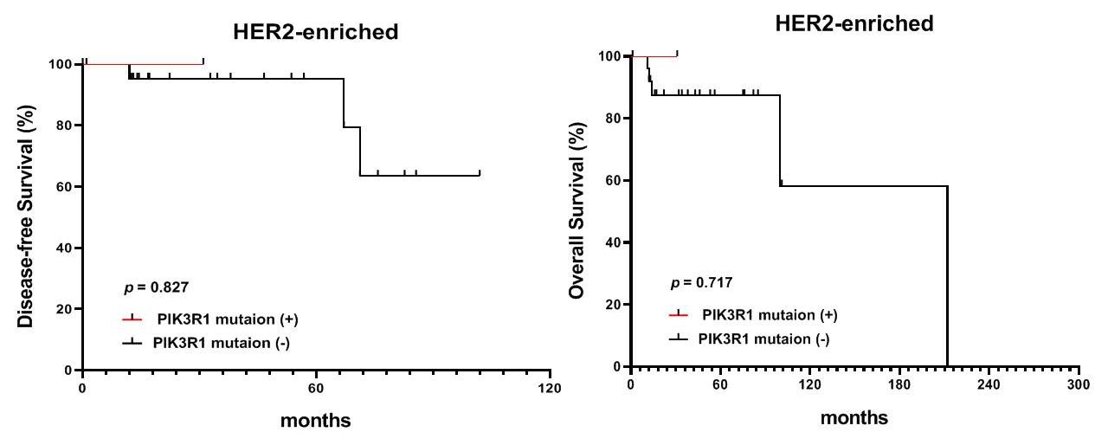

Triple negative (basal-like)

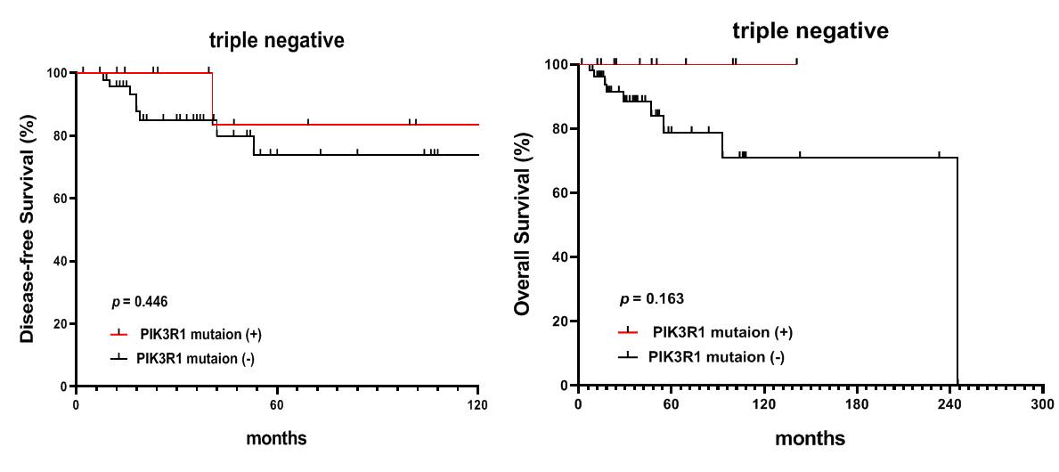

Suppl 6. Correlation between of PIK3R1 gene expression and clinical outcome. Using the Kaplan Meier plotter database, we found that there is a better overall survival (OS)in high PIK3R1 mRNA expression level (212240_s_at) compared to those with low PIK3R1 mRNA expression tumors in luminal A (ER+/HER2 low) subtype (p =0.0018). There was a trend of positive correlation betweenPIK3R1 mRNA expression (212240_s_at) in patient OS in luminal B (ER+/HER2 high, p=0.27) and HER2-enriched (p=0.49) subtypes. In contrast, no correlation between PIK3R1 mRNA expression (212240_s_at) in patient OS in triple negative subtype (p=0.84).

