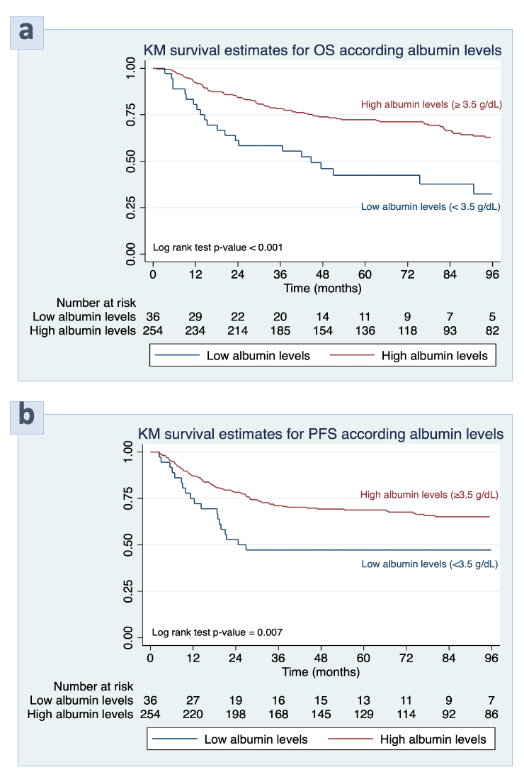
Suppl. Figure 1. Kaplan-Meier curves of a) overall survival and b) progression-free survival of epithelial ovarian clear cell cancer patients stratified by albumin levels

