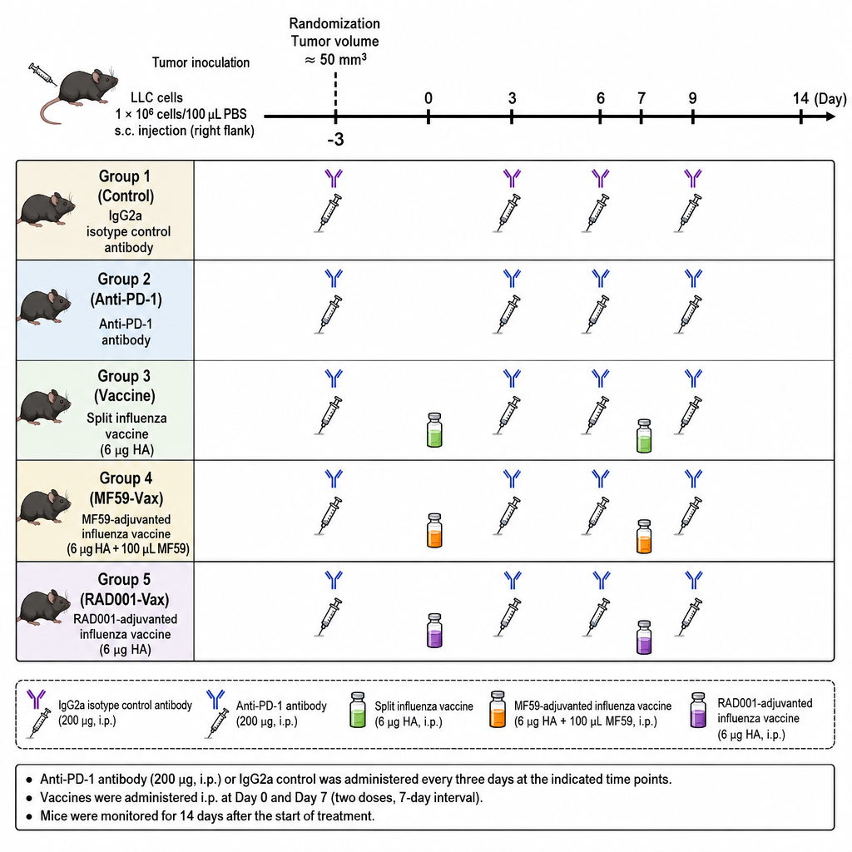
Suppl 1. Treatment timeline schematic. LLC tumor-bearing mice were randomized into five groups when tumor volume reached approximately 50 mm³. Anti-PD-1 antibody or IgG2a isotype control antibody was administered intraperitoneally every three days. The first anti-PD-1 administration was performed three days before the first vaccination. Influenza vaccine formulations were administered intraperitoneally on Day 0 and Day 7. Tumor growth was monitored for 14 days after treatment initiation.

