Suppl 3. Morphological analysis of HL60 cells treated with ATRA over three time points.
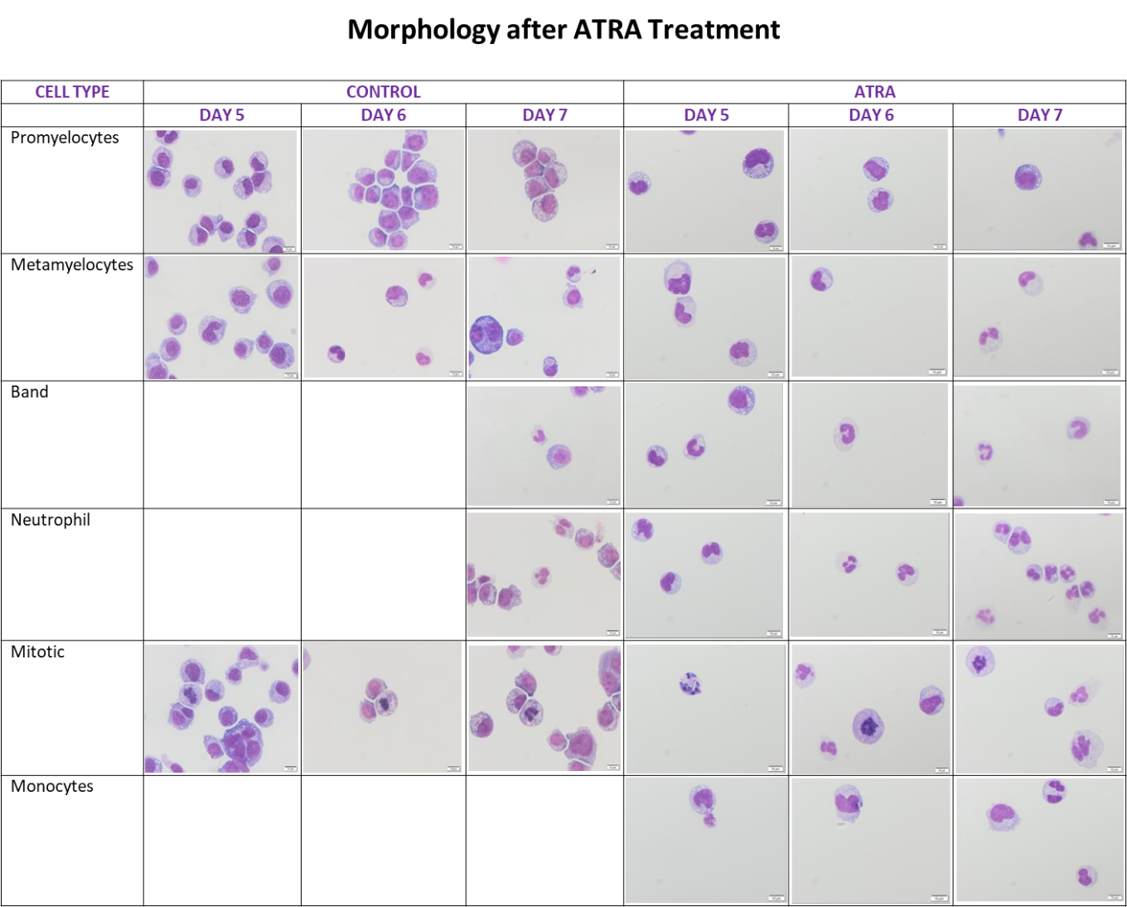
Giemsa-stained cytospin preparations of HL60 cells were examined on days 5, 6, and 7 to assess morphological changes. Compared with untreated control cells, ATRA-treated HL60 cells gradually transitioned from a promyelocyte morphology to mature neutrophil forms. Representative images highlight the progression of differentiation across time points. Scale bar = 10 µm.

