**Suppl 2.** Monocytic differentiation of HL-60 cells induced by ATRA.

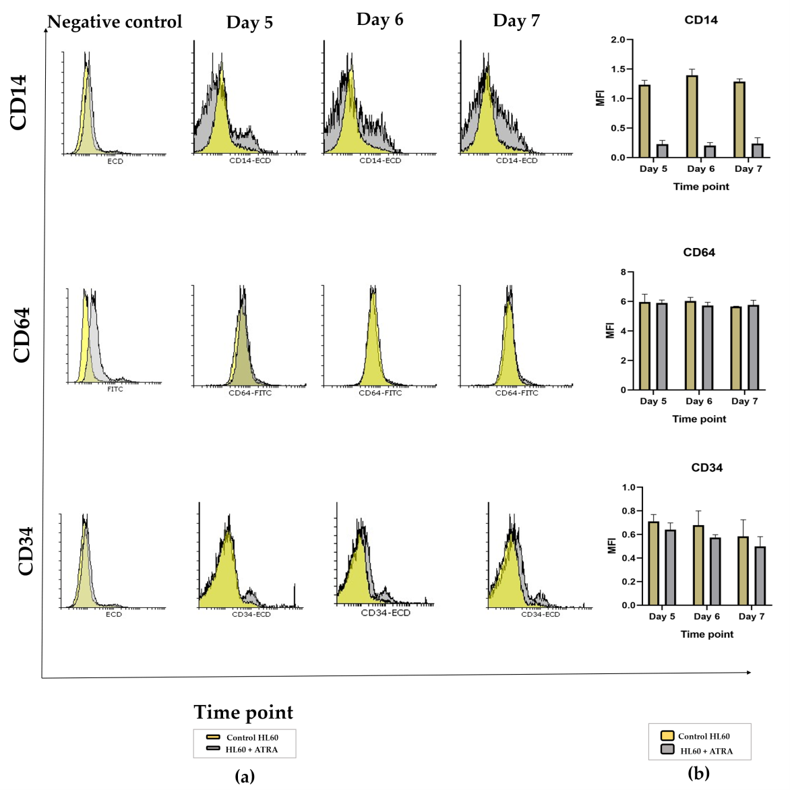

Analysis of the monocytic maturation of HL60 leukemia cells following ATRA induction: (a) Representative histogram plots of CD14, CD64 and CD34 markers on day 5 (left panel), day 6 (middle panel) and day 7 (right panel) comparing the ATRA-treated HL60 cells (gray shading) with the untreated controls (yellow shading). All negative controls (left panel) represent an overlay histogram of the MFI of the HL60 control and ATRA-treated cells with no Ab control. (b) Mean fluorescence intensity of the same markers in ATRA-treated HL60 cells for 5 days, 6 days or 7 days (gray bar) or control HL60 cells (yellow bar), n = 3; error bars =SEM; \**p*≤0.05, \*\**p*≤0.005, \*\*\**p*≤0.0005. Abbreviations: ATRA, all-trans retinoic acid; SEM, standard error of mean.