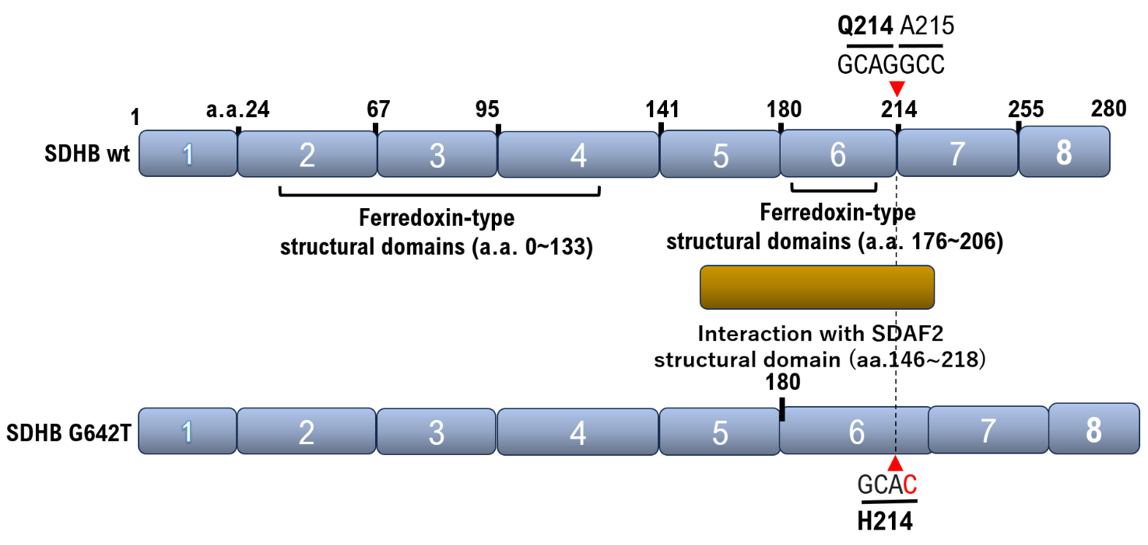**A**

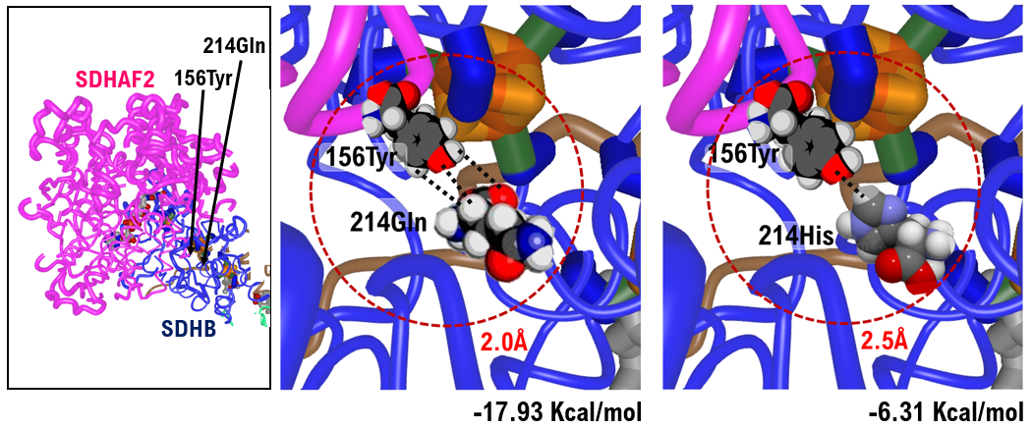**B**

**Suppl 4.** The SDHB G642T variant is unable to bind to the SDAF2 due to the mutation. Therefore, this mutant cannot perform its normal function. **A**. The exocytosis of SDHB and the region where the structural domain is located are described. SDHAF2 is a regulatory factor that acts as a chaperone protein for SDH and assists in the normal assembly and stabilization of the enzyme complex. The structural domain of SDHB binds to SDHAF2 and recruits the Fe-S family proteins to form a complex that helps to regulate the activity of SDH and to carry out the ensuing reactions, such as redox and electron transfer. **B.** To examine the extent to which the binding ability between SHDB and SDAF1 is affected by the glutamine-to-histidine mutation, we performed in silico analysis. To examine the extent to which the binding ability between SHDB and SDAF1 is affected by the glutamine-to-histidine mutation, we performed *in silico* analysis. *In silico* analysis showed that glutamine 214 of SHDB has affinity for histidine 156 of SDAF2. The affinity between glutamine 214 of SHDB and tyrosine 156 of SDAF2 was found to be -17.93 Kcal/mol. On the other hand, although the histidine 214 of the SHDB mutant has affinity for the tyrosine 156 of SDAF2, the affinity between histidine 214 of SHDB and tyrosine 156 of SDAF2 was found to be weak, at -6.31 Kcal/mol. In other words, the results of *in silico* analysis revealed that the SHDB 214His mutant may have a much weaker binding affinity to SDAF2 than the wild-type SHDB.